问题描述

安装好SourceTree后，首次使用时，需要通过账户登录，但注册或登录界面可能根本无法打开，导致无法进入软件   
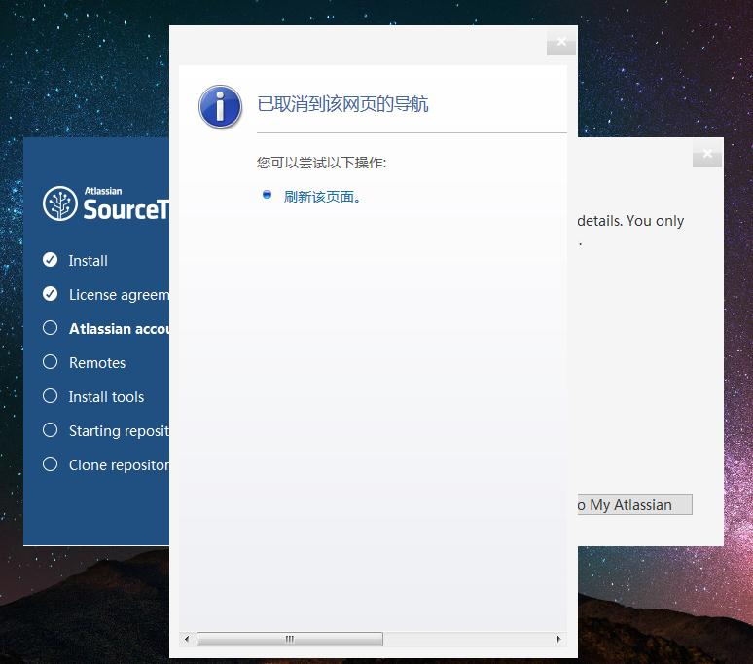

解决办法

在目录C:\Users\{youruser}\AppData\Local\Atlassian\SourceTree 下创建文件accounts.json ，注意：{youruser}需要替换为登录系统用户名。

写入如下内容：

[

{

"$id": "1",

"$type": "SourceTree.Api.Host.Identity.Model.IdentityAccount, SourceTree.Api.Host.Identity",

"Authenticate": true,

"HostInstance": {

"$id": "2",

"$type": "SourceTree.Host.Atlassianaccount.AtlassianAccountInstance, SourceTree.Host.AtlassianAccount",

"Host": {

"$id": "3",

"$type": "SourceTree.Host.Atlassianaccount.AtlassianAccountHost, SourceTree.Host.AtlassianAccount",

"Id": "atlassian account"

},

"BaseUrl": "https://id.atlassian.com/"

},

"Credentials": {

"$id": "4",

"$type": "SourceTree.Model.BasicAuthCredentials, SourceTree.Api.Account",

"Username": "username@email.com"

},

"IsDefault": false

}

]

重新启动软件，顺利进入界面   
